Cully Green - Purchase Offer Cover Sheet

This form should be signed and delivered to the seller’s agent (in hard copy or by e-mail), accompanied by the following documentation:
- Executed Unit Sale Agreement
- Evidence of financial capacity to close on purchase (Lender pre-approval letter, Proof of Funds…)
- Signed ‘receipt of Disclosures’ and ‘receipt of Declaration & Bylaws’ forms, (per condo requirements)

All information shared on this form will be kept entirely confidential.

Buyer household name(s): ________________________, _____________________, ______________________, ___________________, _________________

Address (4-digit number) | Offer Price | Any notes

Parking Space request ($15K): 1st choice: _______________, 2nd choice: __________________, 3rd choice: ________________________

Down payment: $____________ . Balance financed through: ____________________________________________(lender name)

Please share a little information about your household and why you’d like to live in this community (below or in an attached letter). To assist us in complying with fair housing, please do not include photos of household members.
__________________________________________________________________________________________________________________
__________________________________________________________________________________________________________________
__________________________________________________________________________________________________________________
__________________________________________________________________________________________________________________

______ Initial that you’ve read and support the Vision & Values statement (https://www.cullygreenpdx.com/legal-docs)

______ Initial that you’ve read Section 8 of the Bylaws (and ideally the entire Declaration & Bylaws), and that even if there are a few parts that you would have written differently, there is nothing in it that would need to be changed in order for you to happily and comfortably live in this community. We mention this because although technically these rules can be changed by the association post-occupancy, this cannot be counted on.

Once at least half of the homes are in escrow, buyers with accepted offers will be invited to attend a meet-and-greet potluck. To assist in scheduling, please share your e-mail address(es):_____________________________, _______________________________

Optional Additional Information
If you would like to submit alternative offers in case your first choice is not available, please use the table below to do so.
Back-up choices | Address | Offer Price | Any notes
1
2
3
4
5
6

Are there any other households you’re hoping to be neighbors with in this community who are also submitting offers?
- Household Name: ___________________. We (Would / Would not) buy without this household being included
- Household Name: ___________________. We (Would / Would not) buy without this household being included
- Household Name: ___________________. We (Would / Would not) buy without this household being included

Dated this ____________ day of _______________, 2019.

Signature(s): ________________________________________, ________________________________________
NOTICE TO PURCHASER
(RIGHT OF CANCELLATION)
By signing this unit sales agreement you are incurring a contractual obligation to purchase an interest in a condominium. However, you have the right to cancel this agreement for any reason for five (5) business days (excluding Saturdays and holidays) after whichever of the following is last to occur:
1. Signing by the purchaser of the unit sales agreement;
2. Signing by the purchaser of the receipt for the disclosure statement, if any; or
3. Signing by the purchaser of the receipt for a copy of the condominium declaration and bylaws and any amendments or supplements thereto affecting the unit.
To cancel this agreement, you must give written notice to the developer or the agent of the developer at the following address:
CULLY GREEN LLC
4751 NE GOING ST.
Portland, OR 97218

Attn: Eli Spevak
(Suggested Procedure)
Before executing this agreement, or before the cancellation period ends, you should do the following:
4. Carefully examine the disclosure statement, if any, issued by the real estate commissioner on the condominium and all accompanying information delivered by the developer. Oregon law requires the developer to deliver to you a copy of the declaration and bylaws of the condominium and any supplements and amendments thereto affecting the unit prior to the time the unit sales agreement is fully executed by all parties. A copy of the declaration and bylaws, and any supplements and amendments thereto, are available from the association for examination and duplication, at a reasonable fee, upon your written request.
5. Inquire of your lender whether you can get adequate financing on an acceptable basis.
6. Inquire of the developer and the lender what the amount of the closing costs will be.
Oregon law requires that you immediately be given a copy of this notice and a copy of the unit sales agreement when it has been fully executed by all parties.
FINAL AGENCY ACKNOWLEDGMENT
Both Purchaser and Seller acknowledge having received the Oregon Real Estate Agency Disclosure Pamphlet required by ORS 696.820 and hereby acknowledge and consent to the following agency relationship(s) in this transaction:
1. ____________________ (Name of Buyer’s Agent), Oregon Lic. # ____________ of ____________________(Name of Real Estate Firm). Buyer’s Agent’s Office Address: _______________________________________. Company Lic. # ______________________ Phone ______________ Fax ___________________ E-mail ________________________ is/are the agent of (check one):  Buyer exclusively (“Buyer Agency”) or  Both Buyer and Seller (“Disclosure Limited Agency”).
2. ____________________ (Name of Seller’s Agent), Oregon Lic. # ____________ of ____________________(Name of Real Estate Firm). Seller’s Agent’s Office Address: _______________________________________. Company Lic. # ______________________ Phone ______________ Fax ___________________ E-mail ________________________ is/are the agent of (check one):  Seller exclusively (“Seller Agency”) or  Both Buyer and Seller (“Disclosure Limited Agency”).
3. If both parties are each represented by one or more Agents in the same Real Estate Firm, and the Agents are supervised by the same principal broker in that Real Estate Firm, Buyer and Seller acknowledge that said principal broker shall become the disclosed limited agent for both Buyer and Seller as more fully explained in the Disclosed Limited Agency Agreements that have been reviewed and signed by Buyer, Seller and Agent(s).
4. Purchaser shall sign this acknowledgement at the time of signing this Unit Sales Agreement before submission to Seller. Seller shall sign this acknowledgement at the time this Unit Sales Agreement is first submitted to Seller, even if this Unit Sales Agreement will be rejected or a counter offer will be made. Seller's signature to this Final Agency Acknowledgement shall not constitute acceptance of the Unit Sales Agreement or any terms therein.
ACKNOWLEDGED
Purchaser:________________________ Dated: __________________
Purchaser:________________________ Dated: __________________
Seller:
CULLY GREEN LLC, an Oregon limited liability company
By:_______________________________
Eli Spevak, Managing Member
CULLY GREEN CONDOMINIUM
UNIT SALES AGREEMENT
(AND RECEIPT FOR EARNEST MONEY)
DATED: __________________________, 201___
BETWEEN: Cully Green LLC, (“Seller”)
an Oregon limited liability company
4751 NE Going St.
Portland, OR 97218
Attn: Eli Spevak
Telephone: (503) 422-2607
Email Address: eli@orangesplot.com
AND: ________________________________________________________
________________________________________________________
whose address is
________________________________________________________
________________________________________________________
________________________________________________________
Telephone: Office: ___________________________________
Home: _____________________________________________
Mobile:_____________________________________________
Facsimile:___________________________________________
Email Address: ______________________________________ (“Purchaser”)
This Unit Sales Agreement (this “Agreement”) provides for the acquisition by Purchaser of Living Unit _______(Address: ______ NE Going St./ ______ NE 47th St.) and Parking Unit ______ of Cully Green Condominium (the “Condominium”), a condominium project located at 4744 - 4798 NE Going Street/4540 – 4584 NE 47th Street, in the City of Portland, Multnomah County, Oregon, including the interest in the common elements of the Condominium (the “Common Elements”) pertaining to such real property, for a purchase price of $_______________ for the Living Unit and $ for the Parking Unit (together, the “Purchase Price”). Living Units each include a range (gas for Living Unit 16; induction for all others), Energy-Star rated refrigerator, micro-hood, and dishwasher.
The Living Unit and/or Parking Unit are referred to collectively herein as the “Unit.” “Seller” as used in this Agreement shall mean Cully Green LLC and any successor or assignee of its rights and obligations under this Agreement pursuant to Section 16.3 below.
Summary of Terms of Payment:
Purchase Price $____________________
Payable as follows:
Earnest money deposit paid upon execution of this Agreement: $____________________
At or before Closing, the balance of down payment: $____________________
Balance due at closing as agreed in Financing Section (13) of the Agreement
(excluding closing costs): $____________________
Closing is anticipated to occur on May 31, 2021 or earlier, subject to the conditions described in Section 3.1.
The purchase and sale of the Unit is subject to the following terms and conditions:

Agreement to Sell and Buy. Seller agrees to sell to Purchaser, and Purchaser agrees to buy from Seller, the Unit, together with the interest in the Common Elements pertaining to the Unit. Purchaser acknowledges that although Purchaser will have exclusive rights to use and enjoy the storage locker, if any, and yard area constituting the portion of limited Common Elements associated with the Unit, this, and all other Common Elements of the Condominiums will be owned by Purchaser jointly with other unit owners as part of Purchaser’s undivided interest in the Common Elements.

Payment of Purchase Price. Purchaser shall pay the Purchase Price as follows:

Earnest Money. Purchaser has paid to Seller the earnest money deposit indicated above in the form of a check. In the event Seller fails to execute and deliver this Agreement within seven (7) days following its execution and delivery by Purchaser, any earnest money paid by Purchaser (and any interest earned on such deposit) or the undeposited check shall be returned to Purchaser. The date upon which this Agreement is fully executed by both Purchaser and Seller is the “Execution Date.” Within three (3) days after the Execution Date, Purchaser shall cause the entire amount of earnest money to be paid in cash equivalent funds into an escrow account maintained by Fidelity National Title Insurance Company (“Escrow Agent”), whose address is 717 NE Holladay St., Portland, OR 97232. Purchaser hereby instructs Escrow Agent to hold and use such sums and all other sums deposited in escrow under this Agreement pursuant to the escrow agreement between Escrow Agent and Seller (the “Escrow Agreement”), a copy of which is attached as Exhibit A. Escrow Agent will deposit the earnest money in a federally-insured, non-interest-bearing account with a bank or other finance institution. Seller and Purchaser understand that, in addition to fees, Escrow Agent receives certain in-kind benefits in connection with administering the escrow deposit.

Payment of Balance. The earnest money deposit described in Section 2.1 and the balance of the Purchase Price shall be paid in cash to Seller in full on the Closing Date (as defined in Section 3).

Closing.

Closing Date. Subject to the terms and conditions of this Agreement, the purchase and sale of the Unit shall be closed on an a business day selected by Seller within 10 days after delivery of a closing notice from Seller to Purchaser given (i) after the Declaration of Condominium Ownership for Cully Green (the “Declaration”) has been recorded and (ii) after the City of Portland has issued a Certificate of Occupancy for the Unit, as determined by Seller, subject to the terms and conditions of this Agreement (the “Closing Date”). In no event shall the Closing Date be later than May 31, 2021. Seller and Purchaser acknowledge that for closing to occur by the date specified in this Agreement, it may be necessary to execute documents and deposit funds with Escrow Agent prior to such date.

Seller’s Termination Right. Seller reserves the right not to record the Declaration and to terminate this Agreement, if unit sales agreements for __ percent of the 23 Living Units for residential, live/work or for commercial use that are expected to be constructed within the Condominium are not in effect on _____________________, 20___ [CAN BE UP TO 180 DAYS AFTER EXECUTION OF FIRST UNIT SALES AGREEMENT]. In such event, Seller may exercise its termination right by written notice given to Purchaser within ten (10) days after such date.

Conveyance. At closing, Seller shall convey the Unit to Purchaser, together with the interest in the Common Elements pertaining to the Unit, by statutory special warranty deed (the “Deed”), free and clear of all liens and encumbrances suffered or created on the Unit by Seller other than the lien of real property taxes and assessments not yet due, easements and restrictions of record as of the Closing Date (excluding any blanket encumbrances imposed by Seller’s lender), the Declaration, Bylaws of the Cully Green Owners’ Association, and any additional public utility easements of record. The closing of this Agreement is expressly conditioned on the partial release of the Unit from any existing mortgage or trust deed or other blanket financial encumbrance on the Condominium.

Escrow. Closing shall occur on the Closing Date at the offices of Escrow Agent, or at such other location as the parties may designate. Seller shall provide Purchaser with at least 10 days’ prior notice of the Closing Date. Both Seller and Purchaser shall execute all closing documents and deliver to Escrow Agent all funds required of such party in connection with the closing at least one (1) day prior to the Closing Date. On the Closing Date, Escrow Agent shall complete the closing pursuant to the Escrow Agreement by recording the Deed and delivering the proceeds of the transaction to Seller.

Possession. Purchaser shall be entitled to possession of the Unit upon recordation of the Deed and disbursement of the Purchase Price to Seller.

Taxes and Assessments. Real property taxes and assessments, including, without limitation, assessments levied by the Cully Green Owners’ Association (the “Association”), shall be prorated as of the Closing Date. If actual tax and/or assessment information is not available as of the Closing Date, Escrow Agent will be permitted to utilize estimates in order to complete the Closing.

Closing Costs and Other Payments. Purchaser shall pay at closing (i) a contribution to the working capital fund of the Association in an amount equal to two (2) months of Association assessments applicable to the Unit; (ii) Purchaser’s prorated share of the Association assessments for the month in which the closing occurs; (iii) one-half of Escrow Agent’s escrow fee; (iv) all recording costs; (v) the premium for any extended coverage endorsement to the standard coverage title insurance policy or extended coverage policy against construction liens, as described in Section 3.7, and (vi) any fees, costs, and expenses incurred in connection with Purchaser’s financing not previously paid by Purchaser. Seller shall pay at closing the premium for the title insurance policy described in Section 3.7, the remaining balance of Escrow Agent’s escrow fee, and any recording costs for any releases obtained from Seller’s lender.

Title Insurance. It shall be a condition to closing that Escrow Agent shall be prepared to deliver to Purchaser within a reasonable time after closing a standard coverage owner’s policy of title insurance in the amount of the Purchase Price insuring title to the Unit in the name of Purchaser, except for the usual printed exceptions to such policies and those matters described in Section 3.2. Purchaser shall pay the premium of any extended coverage endorsement to the standard coverage title insurance policy, if such endorsement is required by Purchaser’s lender or is otherwise requested.

Default.

By Seller. In the event that Seller fails to perform its obligations under this Agreement in a timely manner, and fails to cure such default within 30 days after notice from Purchaser to Seller specifying in reasonable detail such default, Purchaser shall have the right to terminate this Agreement by notice to Seller and Escrow Agent. Upon such termination, Purchaser shall be entitled, as its sole remedy, to recover the entire amount paid to Escrow Agent, plus any interest earned on such amount. Without limitation, Purchaser shall not be entitled to the remedy of specific performance for a Seller default. IN NO EVENT SHALL SELLER BE LIABLE TO PURCHASER FOR ANY OTHER DAMAGES ARISING OUT OF THE PROVISIONS OF THIS AGREEMENT, INCLUDING, WITHOUT LIMITATION, SPECIAL OR CONSEQUENTIAL DAMAGES OR MOVING COSTS, TEMPORARY HOUSING COSTS, LOSS OF FINANCING, OR INCREASE IN INTEREST RATES. Special or consequential damages for purposes of this Agreement shall include, without limitation, any loss of use, income, or profit or any loss of or damage to property, whether purchased under this Agreement or otherwise.

By Purchaser. Time of Purchaser’s performance is of the essence of this Agreement. In the event Purchaser fails to make any payment required under this Agreement within five (5) days after notice from Seller that such payment is due, fails to close its purchase of the Unit when required herein, or to perform any other obligation of Purchaser under this Agreement and fails to cure such default within 10 days after notice from Seller specifying in reasonable detail such default, Seller may declare Purchaser to be in default of this Agreement by notice to Purchaser and may, in addition to exercising all other remedies available to Seller under this Agreement, at law, or in equity, terminate this Agreement. UPON SUCH TERMINATION, THE ENTIRE AMOUNT PAID BY PURCHASER UNDER THIS AGREEMENT, PLUS ANY INTEREST EARNED ON SUCH AMOUNT, MAY, AT SELLER’S SOLE OPTION, BE RELEASED TO SELLER AND RETAINED BY SELLER AS LIQUIDATED DAMAGES WITH RESPECT TO SUCH DEFAULT. Seller’s election not to terminate this Agreement shall not preclude Seller from thereafter electing to terminate this Agreement and receive the entire amount paid by Purchaser under this Agreement, plus any interest earned thereon. Seller’s election regarding whether or not to retain such amounts as liquidated damages may be exercised arbitrarily and in Seller’s sole and absolute discretion. Without limitation of any other rights of Seller, in the event Purchaser fails to close this transaction at the scheduled closing, then closing may be extended at Seller’s option, for any number of days past the scheduled Closing Date as determined by Seller in Seller’s sole discretion (the “Extension Period”). As additional liquidated damages for the closing delay, that portion of the closing costs which Purchaser is obligated to pay shall be increased by $50.00 per day for each day of the Extension Period commencing on the scheduled Closing Date and continuing until and including the actual Closing Date. That portion of the closing costs which Seller would otherwise have been obligated to pay shall be decreased by the same amount. At any time during the Extension Period, Seller may elect to require that the closing occur by giving Purchaser written notice of the date on which the closing must occur (the “Revised Closing Date”). Seller’s remedies under this Section 4.2 are cumulative and may be pursued concurrently, independently, or successively, in any order whatsoever. The parties acknowledge the difficulty of determining the actual damages resulting from a default by Purchaser under this Agreement and agree that the liquidated damages described in this Section 4.2 represent a reasonable estimate of such damages and are not a penalty.

Receipt and Approval of Documents. Seller has furnished to Purchaser the following documents:

State of Oregon Disclosure Statement for the Condominium;

Proposed Declaration;

Proposed Bylaws and Articles of Incorporation for the Association;

Notice to Purchaser (Right of Cancellation) (attached to the front of this Agreement); and

Escrow Agreement (see Exhibit A).
Purchaser has received and read such documents and accepts and agrees to be bound by their respective provisions, as these may be modified in accordance with Section 6. Purchaser acknowledges that the Bylaws impose certain limitations on the ability of owners to use Units for commercial purposes or to lease Units to third parties.

Amendment of Documents. The documents described in Section 5, as well as the plat for the Condominium, may be modified by Seller prior to closing. Subject to the terms of this Section 6, in the event of a modification of any of these documents prior to closing that materially and adversely affects Purchaser, Seller shall give Purchaser notice of such modification and Purchaser shall have the right to terminate this Agreement by notice to Seller and Escrow Agent given during the period ending 10 days after Seller’s notice to Purchaser. In the event of such termination, Purchaser’s sole remedy shall be the return of the amount it previously paid to Escrow Agent, plus any interest earned on such amount. If Purchaser fails to terminate this Agreement during such 10-day period, Purchaser shall be deemed to have accepted such modifications. This Agreement shall not be affected by, nor shall the consent of or notice to Purchaser be required with respect to (i) modifications of these documents not materially and adversely affecting Purchaser, (ii) minor variations in Unit size from those shown on marketing materials, (iii) the design, plan, or appearance of other units within the Condominium, (iv) reasonable changes to these documents required by governmental authorities, lenders, or title insurance companies, or (v) any changes to conform to or utilize the provisions of any amendments to the Oregon Condominium Act or revisions to applicable federal or state law, Fannie Mae guidelines or Fannie Mae, Federal Housing Authority or Veterans Affairs regulations prior to closing.

Brokerage; Agency Disclosure.

Brokerage. Buyer is represented by (select one):  ______________ of ______________________________  None (“Buyer’s Broker”). Each party to this Agreement shall indemnify and hold harmless the other from and against any liability, loss, cost, or expense, including reasonable attorneys’ fees, resulting from a claim by a realtor, broker, or agent for a commission or other compensation in connection with the sale of the Unit (other than the commission(s) or fee(s) described in the preceding sentence), to the extent the claim is attributable to such party. If “None” is selected in the sentence above identifying Buyer’s Broker, Buyer warrants that no real estate broker or other person is entitled to a commission resulting from Buyer’s purchase of the Unit, in which event no commission will be paid other than to Seller’s Broker. Buyer acknowledges that Buyer’s Broker has acted as Buyer’s agent and Seller is not responsible for any representations or statements of Buyer’s Broker.
Selling Agent: | Listing Agent:
Name:_______________________________ | Name: Amber Turner of Think Real Estate
Address:_____________________________  _____________________________ | Address: 2923 NE Broadway  Portland, OR 97232
Telephone:___________________ (office) | Telephone: (503) 847-2722 (office)
Facsimile:  Mobile: _____________________________  Broker License No. | Facsimile: ____________________________  Mobile: ______________________________  Broker License No. 200507324

Warranties and Disclaimers. Seller hereby warrants to Purchaser and to the Association (as to general Common Elements only) that it shall replace or repair, as Seller may elect in its sole discretion, any defective plumbing, electrical, mechanical, structural, or other components of newly constructed Units and newly constructed Common Elements constructed by Seller on the terms and conditions contained in this Section 8. “Newly constructed” shall have the meaning set forth in ORS 100.185(3).

[INCLUDE FOR THE SALE OF LIVING UNIT 16: No Warranty for Living Unit 16. Purchaser acknowledges that Living Unit 16, which is being acquired by Purchaser, was built in approximately 1947 and is not “newly constructed” as that phrase is defined in ORS 100.185(3). Accordingly, Purchaser acknowledges that Seller is not providing any warranty with respect to Living Unit 16, which is being sold AS IS, WHERE IS and with all faults, if any.
Purchaser’s Initials:____________/___________]

Units and Associated Limited Common Elements. The warranty given in this Section 8 with respect to the newly constructed Units and associated, newly constructed limited Common Elements shall expire on the first anniversary of the date on which Purchaser is given possession of the newly constructed Unit pursuant to Section 3.4. Seller shall be responsible for defects claimed by Purchaser in connection with the newly constructed Unit and associated, newly constructed limited Common Elements only if a written claim reasonably specifying the breach of warranty is delivered to Seller in accordance with Section 16.1 prior to expiration of the warranty.

General Common Elements. The warranty given in this Section 8 with respect to the newly constructed general Common Elements shall be in favor of Purchaser and the Association and shall expire on the first anniversary of the date of the first conveyance of a unit in the Condominium to a unit owner other than Seller. Seller shall be responsible for defects claimed by Purchaser or the Association in connection with the newly constructed general Common Elements only if a written claim reasonably specifying the breach of warranty is delivered to Seller in accordance with Section 16.1 within two (2) years following the expiration of the warranty; provided, however, that any such claim must be for a defect existing prior to the expiration of such warranty.

Opportunity to Cure. Following receipt of a notice of written claim of breach of warranty in accordance with Section 8.2 or 8.3 above (the “Defect Notice”) and to the fullest extent allowed by law, Seller shall have the opportunity to investigate and to cure any such claim as generally described in Section 8.12 below.

Limitation on Actions. No action to enforce any warranty given in this Section 8 may be commenced after the fourth anniversary of the expiration of such warranty.

Personal Property. Purchaser acknowledges that any warranties on appliances, equipment, and other consumer products as defined in the Magnusson-Moss Warranty Act or the Uniform Commercial Code installed in the Unit are those of the manufacturer or supplier only, that Seller does not warrant such items, but that, to the extent assignable, these manufacturers’ or suppliers’ warranties will be assigned to Purchaser effective on the Closing Date. Seller shall reasonably cooperate with any such claims Purchaser may elect to pursue against the manufacturer, provided there is no cost or liability to Seller. If Seller receives any payment from a manufacturer after closing as a result of product deficiencies applicable to the Unit, Seller shall deliver such payment to Purchaser after deduction of Seller’s costs. Seller does not represent or guaranty the existence or validity of any manufacturer or supplier warranties or the performance by any manufacturer or supplier of its warranty obligations. With respect to any manufactured products, Purchaser expressly assumes the risk, as against Seller, that such products may be deficient, substandard or defective. Purchaser also acknowledges that the warranty of all appliances, equipment and other consumer products placed in the Common Elements by Seller, if any, are those of the manufacturer or supplier only, that Seller does not warrant such items.

No Other Warranties. TO THE FULLEST EXTENT PROVIDED BY LAW, SELLER MAKES NO OTHER WARRANTIES, EXPRESS OR IMPLIED, INCLUDING, WITHOUT LIMITATION, WARRANTIES OF HABITABILITY, MERCHANTABILITY OR FITNESS FOR A PARTICULAR PURPOSE OR ANY WARRANTIES REGARDING CONSUMER PRODUCTS AS DEFINED IN THE MAGNUSSON-MOSS WARRANTY ACT OR THE UNIFORM COMMERCIAL CODE, WITH RESPECT TO THE BUILDING, THE UNIT, COMMON ELEMENTS, OR ANY OTHER PART OF THE CONDOMINIUM (THE “PROPERTY”) OTHER THAN THOSE EXPRESSLY DESCRIBED IN THIS SECTION 8. PURCHASER ACCEPTS THE PROPERTY IN ITS AS IS CONDITION AT CLOSING, WITHOUT REPRESENTATION OR WARRANTY OF ANY KIND EXCEPT FOR THE EXPRESS WARRANTY OF THIS SECTION, IF ANY. WITHOUT LIMITATION TO THE FOREGOING, AND EXCEPT FOR THE EXPRESS WARRANTY OF THIS SECTION 8, SELLER MAKES NO REPRESENTATION OR WARRANTY REGARDING (I) COMPLIANCE WITH APPLICABLE BUILDING CODES, (II) ACOUSTICS, CONSISTENCY OF FLOOR SLOPE, OR SOUND TRANSFERENCE WITHIN THE CONDOMINIUM, (III) LIGHT, AIR OR VIEW, OR (IV) THE ABILITY OF THE BUILDING ENVELOPE OR ANY COMPONENTS OF THE CONDOMINIUM TO WITHSTAND WATER INTRUSION. Seller shall not be responsible for damage to the Unit, Common Elements, or the Condominium (i) caused by normal wear and tear; (ii) caused by Purchaser, the Association, or other parties, whether by misuse, abuse, failure to properly maintain the Unit and Common Elements, or otherwise; (iii) exacerbated by Purchaser, the Association, or other parties, or allowed by Purchaser or the Association to be exacerbated, including, without limitation, damages exacerbated by Purchaser or the Association, as applicable, failing to allow Seller access to the Unit or Condominium, as applicable, to perform warranty work; (iv) related to work performed in or on the Unit, Common Elements, or the Condominium by or on behalf of the Purchaser, Association, or parties other than Seller; or (v) any other items covered by a manufacturer’s warranty. Any warranty work performed by Seller and its representatives will be during Seller’s normal weekday hours and Purchaser agrees to provide access therefor in a timely fashion. The warranty term shall not be extended by any warranty repair or replacement work by Seller or its representatives. Seller makes no warranty regarding soundproofing of units and transmission of sounds between units and other areas of the Condominium shall not be considered a construction defect.

No Implied Warranties. The warranty provided by this Section 8 shall be in lieu of any and all implied warranties against defects in the plumbing, electrical, mechanical, structural or other components of the newly constructed Unit or newly constructed Common Elements.

Defects. As used in this Section 8, “defect(s)” or “defective” means a flaw in the materials or workmanship used in constructing the Unit or Common Elements that: (i) materially affects the structural integrity of the Unit or Common Elements; (ii) has an obvious and material negative impact on the appearance of the Unit or Common Elements; (iii) jeopardizes the life or safety of the occupants of the Unit; or (iv) results in the inability of the Unit or the applicable Common Elements to provide the functions that can reasonably be expected in a condominium dwelling. So long as the Unit is completed substantially in accordance with Seller’s plans and specifications, minor deviations and variations therefrom such as, without limitation, paint color, window and floor coverings, countertops and cabinets, appliances, plumbing and electrical fixtures, hardware and other decorations, and other finish work shall not be considered “defects.” Deficiencies inherent in the quality of a particular component or element of the Unit or Common Elements shall not be considered defects due to workmanship or materials. Wood grains, veining or other patterns inherent in natural materials such as wood or stone may vary and such variances shall not be considered a “defect.” Conditions caused by or resulting from the failure of Purchaser or the Association to perform normal and routine maintenance of the Unit and Common Elements, as applicable, shall not be considered “defects.”

Noise, Light, Air and View. Developer makes no representation or warranty regarding the existence of or changes in the level of noise, light, air or view benefiting or burdening the Unit specifically or the Condominium generally. Purchaser acknowledges that the Seller will have no liability if the current level of noise, light, air or view affecting the Unit changes due to future developments. Purchaser acknowledges that as is typical in residential condominiums, the Units are not soundproof and Seller makes no warranty or representation regarding the degree that exterior sounds will infiltrate the Unit. Unit occupants may hear some degree of noise from the nearby streets, railroad tracks and Portland International Airport, from nearby residences and businesses and from nearby common areas. The Association, and not Seller, will have the responsibility of enforcing rules against disturbing other members of the Association, but even reasonable levels of noise occurring outside the Unit may be audible inside the Unit to some degree. Purchaser should obtain independent advice from its design consultants regarding any question concerning sound transmission and any additional insulation desired at Purchaser’s expense to further soundproof the Unit beyond what is standard. Purchaser also acknowledges that any removal of the finished flooring or other alterations within the Unit or Condominium may adversely affect the noise levels within the Unit.

Mold.

Basic Information About Mold. According to the U.S. Environmental Protection Agency (the “EPA”), “molds are part of the natural environment. Outdoors, molds play a part in nature by breaking down dead organic matter such as fallen leaves and deed trees, but indoors, mold growth should be avoided.” U.S. Environmental Protection Agency. A Brief Guide to Mold, Moisture and Your Home (EPA Document 402-K-02-003), 2002. Molds reproduce through airborne mold spores. According to the EPA report, mold may begin growing inside of a home “when mold spores land on surfaces that are wet. There are many types of mold, and none of them will grow without water or moisture.” The EPA has stated that “moisture control is the key to mold control.”

Health Effects of Mold. Indoor mold growth has the potential to cause adverse health effects in some individuals. In another recent publication, the EPA has stated that “[m]olds can produce allergens that can trigger allergic reactions or even asthma attacks in people allergic to mold. [Some mold]s are known to produce potent toxins and/or irritants. Potential health concerns are an important reason to prevent mold growth and to remediate/clean up any existing indoor mold growth.” U.S. Environmental Protection Agency. Mold Remediation in Schools and Commercial Buildings (EPA Document 402-K-01-001), 2001.

Additional Information on Mold. For more information on mold and the health effects of mold, consider consulting the publications referenced above. Websites for the U.S. Environmental Protection Agency (www.epa.gov) and the Centers for Disease Control and Prevention (www.cdc.gov) contain additional information on this issue. A search of other government agencies’ websites may also be helpful.

Minimizing Mold In Your Home. According to the EPA, “it is impossible to get rid of all mold and mold spores indoors; some mold spores will be bound floating through the air and in house dust.” Mold Remediation in Schools and Commercial Buildings (EPA Document 402-K-01-001). Though the presence of mold inside of the home can never be completely eliminated, positive steps can be taken to reduce the occurrence of mold growth. Some of the steps recommended by the EPA are as follows:
(i) When water leaks or spills occur indoors, act quickly. If wet or damp materials or areas are dried 24 – 48 hours after a leak or spill happens, in most cases mold will not grow.
(ii) Clean and repair roof gutters regularly.
(iii) Make sure the ground slopes away from the building foundation so that water does not enter or collect around the foundation.
(iv) Keep air conditioning drip pans clean and the drain lines unobstructed and flowing properly.
(v) Keep indoor humidity low. If possible, keep indoor humidity below 60 percent (60%) (ideally between 30 and 50 percent) relative humidity.
(vi) If you see condensation or moisture collecting on windows, walls or pipes, act quickly to dry the wet surface and reduce the moisture/water source. Condensation can be a sign of high humidity.
(vii) Vent appliances that produce moisture, such as clothes dryers, stoves and kerosene heaters to the outside where possible.
(viii) Use air conditions and/or de-humidifiers when needed.
(ix) Run the bathroom fan or open the window when showering. Use exhaust fans or open windows whenever cooking, running the dishwasher or dishwashing, etc.
(x) Cover cold surfaces, such as cold water pipes, with insulation.
A Brief Guide to Mold, Moisture and Your Home (EPA Document 402-K-02-003).

Disclaimers and Waivers. Seller does not represent, warrant or guarantee that the Unit or the Condominium is free from mold, fungi or other naturally occurring biological agents or pollutants (collectively, “Mold”) or that Mold will not develop within the Unit or the Condominium in the future. Seller disclaims all liability and responsibility to Purchaser or to any other persons or entities for any damages resulting from the presence of Mold within the Unit or the Condominium, including, but not limited to, property damages, personal injury damages, loss of income, emotional distress, death, loss of use, loss of value, adverse health effects or consequential damages of any kind (collectively, “Mold Damages”) and Purchaser specifically waives all claims and causes of action against Seller, its officers, agents and employees in connection with any Mold Damages.

Right of Inspection. By appointment arranged in advance, Seller, its agents and assigns shall have the continuing right, but not the obligation, after the Closing Date to inspect Buyer’s Unit and the Common Elements at reasonable times to inspect, identify and correct any conditions for which Seller could potentially be responsible under this Agreement or the law.

Claims Procedure. Purchaser may not commence arbitration or litigation against Seller or any contractor, subcontractor or supplier for construction defects unless Purchaser has given written notice of the claim and permitted them to view, inspect and respond to the claimed defect, as required by law. See Exhibit C.

Limitation on Other Claims. ANY CLAIMS (OTHER THAN EXPRESS WARRANTY CLAIMS PURSUANT TO SECTION 8) WHICH PURCHASER MAY HAVE, INCLUDING, BUT NOT LIMITED TO, CLAIMS FOR NEGLIGENCE, MISREPRESENTATION, BREACH OF CONTRACT, CONSTRUCTION DEFECTS, OR ANY OTHER NONWARRANTY THEORY, MUST BE BROUGHT ON OR BEFORE THE EARLIER (A) EXPIRATION OF THE APPLICABLE STATUTE OF LIMITATIONS, OR (B) WITHIN ONE (1) YEAR FROM THE DATE OF THE TURNOVER MEETING AS DESCRIBED IN THE BYLAWS, WHETHER SUCH CLAIMS ARISE FROM STATUTE, CONTRACT, TORT OR OTHERWISE FOR DAMAGES TO PROPERTY OR PERSONAL INJURY NOW EXISTING OR ARISING AFTER THE DATE OF THIS AGREEMENT AND RELATING TO OR ARISING IN OR FROM ANY OF THE FOLLOWING: (A) DEFECTS, REPAIRS, REPLACEMENTS OR MODIFICATIONS TO THE UNIT OR COMMON ELEMENTS EXCEPT AS SPECIFICALLY COVERED BY THE WARRANTY CONTAINED IN THIS SECTION 9; (B) FAILURE TO COMPLY WITH CODE, NONCOMPLIANCE WITH PLANS AND SPECIFICATIONS, DEFECTIVE CONSTRUCTION, NEGLIGENT CONSTRUCTION AND/OR NON-WORKMANLIKE CONSTRUCTION; (C) TORT AND/OR UNLAWFUL TRADE PRACTICES VIOLATIONS, EMOTIONAL DISTRESS, FRAUDULENT, INTENTIONAL, NEGLIGENT OR INNOCENT MISREPRESENTATION, NEGLIGENCE OR GROSS NEGLIGENCE, NUISANCE, AND/OR TRESPASS; (D) BREACH OF CONTRACT, BREACH OF EXPRESS WARRANTY AND/OR BREACH OF IMPLIED WARRANTIES, INCLUDING THE WARRANTIES OF PROFESSIONAL CONSTRUCTION AND REASONABLE WORKMANLIKE CONSTRUCTION; (E) BREACH OF FIDUCIARY DUTY BY THE SELLER PRIOR TO OR AFTER THE DATE CONTROL OF THE ASSOCIATION IS TURNED OVER TO THE UNIT OWNERS; (F) WATER INTRUSION, WATER INFILTRATION, OR WATER PENETRATION; (G) PRODUCTS OR SUBSTANCES FOUND IN OR USED IN THE UNIT OR COMMON ELEMENTS, INCLUDING, FOR EXAMPLE PURPOSES ONLY, RADON; (H) THE CONDITION OF THE UNIT AND/OR COMMON ELEMENTS; (I) PURCHASER'S LOSS OF USE OF THE UNIT AND/OR COMMON ELEMENTS AND/OR THE LOSS OF VALUE THEREOF; AND (J) CONSEQUENTIAL DAMAGES OR EXPENSES FOR ATTORNEY FEES AND/OR RESULTING FROM THE RELOCATION OF PURCHASER OR FROM THE TERMINATION OF THIS AGREEMENT OR DELAYS IN CLOSING, IF ANY, SUCH AS LODGING, COMMISSIONS, INTEREST RATE FLUCTUATIONS, STORAGE, MOVING, MEALS OR TRAVEL EXPENSE. ANY SUCH CLAIMS NOT BROUGHT WITHIN THIS TIME PERIOD WILL BE DEEMED FULLY WAIVED BY PURCHASER, REGARDLESS OF WHEN PURCHASER ACTUALLY DISCOVERED THE ALLEGED BASIS FOR THE CLAIM. FOR PURPOSES OF THIS SECTION 9, A CLAIM IS "BROUGHT" WHEN (A) FOR MATTERS WITHIN THE SMALL CLAIMS COURT JURISDICTION, A COMPLAINT WAS FILED IN THE APPROPRIATE SMALL CLAIMS COURT AND SERVED PROMPTLY ON SELLER OR (B) FOR MATTERS NOT WITHIN THE SMALL CLAIMS COURT JURISDICTION, THE SELLER HAS ACTUAL RECEIPT OF A FILED COMPLAINT BY PURCHASER OR WRITTEN REQUEST FOR ARBITRATION. THIS SECTION 9 SHALL NOT BE DEEMED TO EXPAND A PURCHASER'S RIGHT TO ASSERT ANY NONWARRANTY CLAIMS, WHICH RIGHT SELLER DENIES.
Purchaser’s Initials:____________/___________

Rules and Regulations. Purchaser acknowledges that use and ownership of the Unit is subject to rules and regulations adopted from time to time by the Board of Directors of the Association or the members of the Association, pursuant to the Bylaws.

Purchaser’s Representations and Warranties.

Occupancy of Unit. If Purchaser has initialed this section below, then Purchaser hereby represents and warrants to Seller that Purchaser is acquiring the Unit with the intent to occupy such Unit as Purchaser’s primary or secondary residence for a period of not less than one (1) year beginning on the Closing Date. Purchaser acknowledges that Seller will rely on Purchaser’s representation if Seller elects to seek approval of the Condominium project by FannieMae, FreddieMac or the Department of Housing and Urban Development. If Purchaser has initialed this section below, Purchaser shall provide Seller with evidence from Purchaser’s lender that Purchaser is purchasing the Unit as Purchaser’s primary or secondary residence by no later than thirty (30) business days prior to the Closing Date.
Purchaser’s Initials: ________/________

Anti-Terrorism Laws. Purchaser represents and warrants to Seller that: (a) Purchaser is not named, and is not acting, directly or indirectly, for or on behalf of any person, group, entity, or nation named by the Uniting and Strengthening America by Providing Appropriate Tools Required to Intercept and Obstruct Terrorism Act of 2001, Pub L 107-56, 115 Stat 272 (“USA Patriot Act”), Executive Order No. 13224 or any other Executive Order or the United States Treasury Department as a terrorist, “Specially Designated Nation and Blocked Person,” or other banned or blocked person, entity, nation, or transaction pursuant to any law, order, rule or regulation that is enforced or administered by the Office of Foreign Assets Control (“Blocked Person”); (b) Purchaser is not engaged in this transaction, directly or indirectly on behalf of, or instigating or facilitating this transaction, directly or indirectly on behalf of, any such Blocked Person; and (c) Purchaser’s full, legal, and complete name(s) set forth above. Purchaser is not known as, and does not employ any other names or aliases. Purchaser shall deliver to Seller a valid passport, valid driver’s license or other identification issued by the Department of Motor Vehicles.
In the event Seller learns that Purchaser’s name appears on the list of Blocked Persons maintained by the Office of Foreign Assets Control, Seller reserves the right to delay the closing contemplated by this Agreement pending Seller’s investigation into the matter. If Seller is advised and/or determines that Purchaser is a Blocked Person, Seller reserves the right to terminate this Agreement and/or to take all other actions necessary to comply with the requirements of the Executive Order. The provisions of this Section 11.2 will survive closing and/or termination of this Agreement.

Construction Matters.

Construction of Unit. If the Living Unit is not complete at the time of this Agreement, Seller agrees to complete the Condominium building within two (2) years from the date of this Agreement, subject to delays for causes beyond Seller's reasonable control. Notwithstanding the provisions of Section 4.1 above, Purchaser may specifically enforce the foregoing obligation of Seller to complete the Condominium building within such two-year time period. Seller may substitute materials, equipment, and fixtures of comparable quality for those shown on the plans and specifications.

Continuing Construction. Purchaser understands that construction work on the Condominium and other units within the Condominium may continue for a period of time following closing. Purchaser hereby waives any claims against Seller related to such construction activities by Seller.

Unit Square Footage. Unit square footage may be different from the square footage shown on plans and specifications or advertising brochures, which are based on good faith estimates. Minor variation in size may be seen even between units having the same floor plan.

Purchaser's Access During Construction. Prior to occupancy and during the construction of the Unit, Purchaser is expressly denied access to the Unit at any time without the express consent of the Seller and a pre-arranged appointment with Seller at such times and on such days as Seller may deem appropriate, in Seller's sole discretion. Purchaser hereby acknowledges that during construction there may be periods when the Unit cannot be accessed and Seller shall have no obligation to provide access to the Unit for Purchaser's inspection prior to the orientation outlined in Section 12.6. Any and all access to the Unit shall be at Purchaser's sole risk. Seller shall have the right to limit the number of individuals allowed access to the Unit at any pre-arranged appointment. Only employees and contractors of Seller, acting pursuant to Seller's written instructions and directions, are authorized to work on the Unit. Prior to closing, Purchaser and Purchaser's agents are prohibited from working on the property themselves or from directing others, including, but not limited to, any contractors or subcontractors working on the Unit.

FTC Insulation Disclosure. This disclosure is made a part of this Agreement to comply with Federal Trade Commission rules. The statements made herein are accurate as of the time of installation of the insulation in the newly constructed Living Units and are based on representations by the insulation contractor. All representations as to R-ratings, unless otherwise indicated, are according to manufacturer's calculations. Some settling and minor variation in thicknesses and R-ratings will occur over time.
Item | R-Value | Thickness/Type
Exterior Walls | R-23 | 5.5” blown-in blanket fiberglass
Flat Ceilings | R-49 | 16” Blown-in Cellulose
Slab Edge | R-15 | 3” Closed Cell Rigid Foam
Insulated Windows |  | U – 0.30

Orientation. During Seller’s normal weekday hours, and not sooner than 30 days prior to the anticipated Closing Date, Purchaser shall inspect the Unit with a designated representative of Seller. At the time of such inspection, Purchaser and Seller shall note items to be completed or corrected by Seller in accordance with a punchlist prepared by Seller and to be oriented to the appropriate Unit maintenance items. Seller shall complete or correct the punchlist items within 30 days of the Closing Date or as soon as reasonably practicable thereafter. Except for any punchlist items, which Seller shall correct within 30 days of the Closing Date or as soon as reasonably practicable thereafter, Purchaser agrees to accept the Unit in its condition existing on the date of the foregoing inspection. Purchaser acknowledges and agrees that punchlist items shall in no way delay or interfere with a timely closing.

Unit Inspection. Should Purchaser elect to have an inspection of the Unit conducted by a private licensed inspector, Seller agrees to allow access to the Unit for said inspection subject to the following terms and conditions: (i) the inspection must occur in connection with and at the same time as the orientation described in Section 12.6; (ii) a member representative of Seller will accompany the private licensed inspector to both ensure that the inspection is conducted in a safe manner and to provide feedback relating to the Unit and/or Limited Common Elements of which the inspector may or may not be aware; (iii) such inspection shall be subject to the terms of Section 12.6 above; and (iv) the inspector shall prepare an inspection report and provide a copy of the report to Seller’s representative by the end the orientation. If Seller declines to correct any substantial defective condition in the Unit noted during the inspection and substantiated by the project architect as a substantial defective condition, Purchaser may elect to terminate this Agreement and Purchaser's earnest money deposit, together with any interest earned thereon, shall be refunded. If Purchaser does not elect to terminate this Agreement, Purchaser shall be deemed to have accepted such condition. Section 8.8 shall also apply for purposes of determining whether a particular item is a “defect.” Purchaser understands and agrees that the private inspection is for the purpose of assessing the condition of the elements of the Unit and/or Common Elements. Cosmetic and/or finish work items will be addressed between Purchaser and Seller at the orientation and in accordance with Section 12.6. At all times while on the Condominium property, Purchaser and Purchaser's inspector shall conduct themselves in a cautious and safe matter. Purchaser agrees to indemnify, defend and to hold Seller harmless from any and all damages, injuries, claims and/or losses arising from Purchaser's and inspector's entry onto the Condominium property and from any and all activity relating to the inspection.

License. The sole member of Seller is licensed with the Oregon Construction Contractors’ Board under License No. 170255.

Purchaser’s Financing.

Representation. Purchaser represents that Purchaser has sufficient funds available, or can obtain a loan to close this sale in accordance with this Agreement, and is not relying on any contingent source of funds unless otherwise set forth in this Agreement.

Evidence of Qualification.

Within three (3) days after the Execution Date, Purchaser shall initiate steps to obtain either (i) a letter of pre-qualification from a bank or mortgage company, or (ii) other evidence of availability of funds sufficient to close satisfactory to Seller (each, an “Evidence of Qualification”). Within 10 days after the Execution Date, Purchaser shall provide to Seller and Escrow Agent such Evidence of Qualification.

If Purchaser determines it will be unable to provide Evidence of Qualification, Purchaser may terminate this Agreement by written notice received by Seller not later than the 10th day after the Execution Date, in which case the Earnest Money and any other funds deposited by Purchaser with Escrow Agent will be returned to Purchaser.

If Purchaser does not submit Evidence of Qualification satisfactory to Seller within such 10-day period, Seller may terminate this Agreement by notice to Purchaser identifying such grounds for termination, in which case the Earnest Money and any other funds deposited by Purchaser with Escrow Agent will be returned to Purchaser.

If neither Purchaser nor Seller terminates this Agreement for the grounds set forth above, the Earnest Money and any other funds deposited by Purchaser with Escrow Agent shall become nonrefundable to Purchaser, except to the limited extent provided in Sections 3.1, 4.1 and 6.

Evidence of Financing.

Within 10 days after mutual execution of this Agreement, Purchaser shall provide to Seller and Escrow Agent a copy of a loan commitment or an unconditional statement of availability of funds satisfactory to Seller, with respect to the purchase of the Unit (the “Evidence of Financing”).

If Purchaser does not provide satisfactory Evidence of Financing to Seller and Escrow Agent within the 10-day period, Seller shall have the right, in its sole discretion, to terminate this Agreement by notice to Purchaser, in which event all funds deposited by Purchaser with Escrow Agent (plus any interest earned on such funds) shall be paid to Seller and neither party shall have further obligation to the other.

General. Purchaser shall be solely responsible for payment of all fees, costs, and expenses incurred in connection with financing the purchase of the Units. Purchaser shall be responsible for maintaining the availability of its financing until Closing. Purchaser is encouraged to take advantage of opportunities to lock in its mortgage interest rate but any cost associated therewith shall be paid solely by Purchaser.

Disclosures.

Sound Transmission Disclosure. Where condominium units are built side by side, it is normal to experience some transmissions of sound between those units from music, foot traffic, water traveling in drains, cupboard doors and similar causes. On occasion these sounds are heard in normal conditions with typical noise levels. Purchaser should expect some transmission of sound between units. Seller makes no warranty regarding soundproofing of units and transmission of sounds between units, common elements and areas outside the Condominium shall not be considered a construction defect. Owner further acknowledges that sound levels may differ over time, depending on a variety of factors, and that Owner accepts current and potential future sound levels. The Association, and not Seller, will have the responsibility of enforcing rules against disturbing other members of the Association, but even reasonable levels of noise occurring outside the Unit may be audible inside the Unit to some degree.

No Representations. It is natural during the course of the transaction contemplated in this Agreement for Purchaser to have questions regarding the Unit. In order for the Purchaser to receive authoritative answers, Purchaser must present any questions to Seller in writing. Purchaser understands and agrees that sub-contractors and real estate agents are not authorized to make representations for Seller. Purchaser understands and acknowledges that any statements contained in marketing literature (including Seller’s website), flyers, advertisements and listing agreements are not representations and are all subject to change, and, therefore, are not to be interpreted to expand or modify any terms or conditions contained in this Agreement. Purchaser shall at no time speak with subcontractors or site workers to make changes of any kind or regarding the condition of the Unit or the Common Elements. PURCHASER ACKNOWLEDGES THAT PURCHASER IS NOT RELYING ON ANY REPRESENTATION MADE BY SELLER OR ITS EMPLOYEES OR AGENTS, EXCEPT AS EXPRESSLY SET FORTH IN THIS AGREEMENT.

Owners' Association. Purchaser is aware that the Purchaser will become a member of the Cully Green Condominium Owners' Association (the “Association”) upon closing. Purchaser hereby agrees to abide by the Declaration, Bylaws of the Association, Articles of Incorporation for the Association, the rules and regulations and any other rules and regulations adopted by the Association (whether adopted by the board of directors or the members), and all amendments and supplements to the foregoing and all other recorded covenants, conditions and restrictions. Purchaser acknowledges that Purchaser shall be obligated to pay Association assessments (both operating and reserve). Purchaser acknowledges that failure to pay assessments could result in loss of Purchaser's right to utilize certain common elements at the Condominium, fines, interest and/or lien on, and the foreclosure of the Unit.

Responsibility of Membership. Each member of the Association, including Purchaser, shall be responsible for participating in the administration and management of the Association and in the maintenance of the Condominium social fabric and common elements. Such roles might include service on the Board of the Association, landscape maintenance, coordination or performance of work to maintain general common elements in good condition, or other functions as determined by the Board from time to time. Unless otherwise decided by the Board, the amount of time expected from an owner of a Living Unit with two or more adults will be greater than the time expected of a one adult household. An average of three (3) to four (4) hours per adult per month is a reasonable expectation for successful self-management of the Association. The Board is empowered to create additional policies regarding participation or payment in lieu of participation.

Consensus. Consensus is the primary method of decision-making at all levels of Association governance, except where otherwise required by the Declaration, the Bylaws, or the Act. Using consensus, each member may agree with the matter, disagree with the matter but not block passage, or disagree with the matter and block consensus. If agreed to by consensus at an Association meeting, decision-making can be delegated to a committee or an individual. Members of the Association or the board of directors physically present or present via telephone at a meeting may participate in consensus polling during the course of such meeting. The Board of Directors may adopt rules and regulations pursuant to Section 8.23 of the Bylaws to further define how consensus decision-making will be conducted. Subject to Section 8 of the Declaration, each owner of a Living Unit is entitled to one vote in meetings of members of the Association and on matters requiring the approval of such members. Until Seller has sold 75 percent of the 19 Units, however, Seller will have two votes for each unit it owns (see Section 19 of the Declaration).

Dispute Resolution of Claims Between Seller and Purchaser.

Required Procedure. Seller and Purchaser each agree that all claims, controversies, or disputes, whether they are statutory, contractual, tort claims and/or counterclaims between or among Seller and Purchaser which arise out of or are related to this Agreement or which relate to the interpretation or breach of this Agreement or otherwise arise regarding the Unit, Common Elements or any part of the Condominium (collectively referred to as “claims”) shall be resolved in accordance with the procedures specified herein. The following matters are excluded from this dispute resolution clause and do not constitute claims: (i) judicial or non-judicial foreclosure or any other action or proceeding to enforce a trust deed, mortgage, or land sale contract; (ii) a forcible entry and detainer action; (iii) the filing or enforcement of a mechanic’s lien; (iv) provisional remedies such as injunctions or the filing of a lis pendens; and (v) as set forth in Section 15.7, at the option of Seller, any claims by Seller against Purchaser arising out of the failure of Purchaser to perform its obligations arising prior to the Closing Date or Purchaser’s failure to close its acquisition of the Unit on the Closing Date. The filing of a notice of pending action (lis pendens) or the application to any court having jurisdiction thereof for the issuance of any provisional process remedy described in Rules 79 through 85 of the Oregon Rules of Civil Procedure (or corresponding federal statutory remedies), including a restraining order, attachment, or appointment of receiver, shall not constitute a waiver of the right to mediate or arbitrate under this Section, nor shall it constitute a breach of the duty to mediate or arbitrate. The proceeds resulting from the exercise of any such remedy shall be held by the party obtaining such proceeds for disposition as may be determined by an agreement of the parties pursuant to mediation or by the arbitration award.

Negotiated Resolution. The parties will seek a fair and prompt negotiated resolution of claims and shall meet at least once to discuss and to seek to resolve such claims, but if this is not successful, all disputes shall be resolved in small claims court, by mediation or by binding arbitration as set forth in Sections 15.3, 15.4 and 15.5 below, as applicable.

Mediation. Prior to mediation of any claim, the parties shall have endeavored to resolve disputes through the process set forth in Section 15.2 above. All claims that are not resolved by such process shall be subject to mediation as a condition precedent to arbitration. The request for mediation may be made concurrently with the filing of a demand for arbitration as set forth in Section 15.5 below, but, in such event, mediation shall proceed in advance of arbitration, which shall be stayed pending mediation for a period of 60 days from the date of filing, unless stayed for a longer period by agreement of the parties. All mediation shall be (i) in accordance with the rules of procedure of the Home Seller/Home Buyer’s Dispute Resolution System of the National Association of Realtors and (ii) in Multnomah County, Oregon, with any dispute resolution program available that is in substantial compliance with the standards and guidelines adopted under ORS 36.175, as it may be amended.

Small Claims. All claims that have not been resolved by mediation and which are within the jurisdiction of the Small Claims Department of the Circuit Court of the State of Oregon in Multnomah County shall be brought and determined there, and all parties waive their right to a jury trial with respect to such claims.

Arbitration. Prior to arbitration of any claim, the parties shall have endeavored to resolve disputes through the processes set forth in Section 15.2, 15.3 and 15.4 above, as applicable. All claims that have not been resolved by such processes shall be resolved by binding arbitration. Such arbitration shall be conducted by and pursuant to the then effective arbitration rules of the American Arbitration Association, or another reputable arbitration service selected by Seller. Any judgment upon the award rendered pursuant to such arbitration may be entered in any court having jurisdiction thereof. The obligation to arbitrate shall survive closing of this transaction.

Confidentiality. Purchaser shall keep all discussions of disputes with Seller and Seller’s representatives, all settlements and arbitration awards and decisions confidential and shall not disclose any such information, whether directly or indirectly, to any third parties unless compelled to do so by an order of a court of competent jurisdiction. Purchaser agrees in the event Purchaser breaches its confidentiality obligation that Seller shall be entitled to seek and obtain any and all equitable remedies, including injunctive relief and specific performance and Purchaser hereby waives any claim or defense that Seller has an adequate remedy at law for any such breach and Purchaser agrees that Seller shall not be required to post any bond or other security in connection with any such equitable relief.

Disputes Based on Purchaser’s Breach of Obligations arising under this Agreement Prior to Closing or for Failure to Close. Notwithstanding anything to the contrary set forth in this Agreement, Seller may, at its option and in its sole and absolute discretion, forgo the alternative dispute resolution procedures set forth in Sections 15.2, 15.3, and 15.5 for claims against Purchaser arising out of Purchaser’s failure to perform its obligations arising prior to the Closing Date and elect to file any such claims for breach of contract against Purchaser in the Circuit Court of Multnomah County, Oregon, or in the Small Claims Department of the Circuit Court of Multnomah County, Oregon, if applicable.

General Provisions.

Notices. Any notice or other communication required or permitted to be given or made by either party to the other pursuant to this Agreement shall be in writing. Notices shall be deemed to have been properly given or made if delivered in person to the other party, sent by facsimile to a fax number provided by the receiving party with confirmation of receipt, sent by email (receipt enabled) or if placed in the U.S. Mails, postage prepaid, addressed to the other party at the address designated by the party in this Agreement. Notices shall be deemed received on the date the notice is actually received if hand delivered or three days after mailing in the manner described in the preceding sentence. Either party may, by notice to the other, designate a different address or addresses for notices or other communications intended for such party.

Entire Agreement. THIS AGREEMENT CONSTITUTES THE ENTIRE AGREEMENT BETWEEN PURCHASER AND SELLER WITH RESPECT TO THE MATTERS CONTEMPLATED BY THIS AGREEMENT, AND THERE ARE NO AGREEMENTS, UNDERSTANDINGS, WARRANTIES, OR REPRESENTATIONS BETWEEN PURCHASER AND SELLER EXCEPT AS SET FORTH IN THIS AGREEMENT. PURCHASER IS NOT RELYING ON ANY REPRESENTATION MADE BY SELLER OR ITS EMPLOYEES OR AGENTS, EXCEPT AS EXPRESSLY SET FORTH IN THIS AGREEMENT. THIS AGREEMENT SUPERCEDES ANY RESERVATION AGREEMENT THAT MAY HAVE BEEN EXECUTED BY THE PARTIES. This Agreement cannot be amended except by a written instrument executed by both Purchaser and Seller. Purchaser hereby represents that there are no contingencies to this Agreement, unless expressly set forth herein.

Assignment. Without Seller’s prior written consent, Purchaser shall not assign or transfer its rights or obligations under this Agreement. Subject to such limitation, this Agreement shall be binding upon and inure to the benefit of the parties and their respective successors, assigns, heirs, personal representatives, and administrators.

Waiver. Waiver of performance of any provision of this Agreement shall not constitute a waiver of nor prejudice the party’s right to require performance in the future of the same provision or any other provision. Any waiver under this Agreement shall be in writing signed by the party to be charged.

No Attorney Fees. In the event of any claim determined by mediation, arbitration or by a court of law, each party shall bear their own costs, including, without limitation, filing fees, attorneys' fees, investigation expenses, consultant's fees and expert's fees. the other costs of mediation, arbitration, litigation and other court costs shall be divided and paid equally by the parties. To the extent permitted by law, statutory attorney's fees under the Unlawful Trade Practices Act or any other applicable statute are hereby waived.

Survival. All provisions of this Agreement, the full performance of which is not required prior to or at closing, shall survive closing and be fully enforceable thereafter, except as provided in this Agreement.

Counterparts. This Agreement may be executed in any number of counterparts, all of which together shall constitute one and the same document.

Effect of Copies. Delivery of legible photocopies, facsimile, carbon or NCR copies of an original signed document will be treated the same as delivery of the original.

Severability. If any term or provision of this Agreement or the application thereof to any person or circumstance shall to any extent be invalid or unenforceable, the remainder of this Agreement and the application of such term or provision to persons or circumstances other than those as to which it is held invalid or unenforceable shall not be affected thereby, and each term or provision of this Agreement shall be valid and enforceable to the fullest extent permitted by law.

Governing Law. This Agreement shall be governed by and construed in accordance with the laws of the State of Oregon.

Joint and Several Liability. If Purchaser consists of more than one person or entity, all such persons or entities shall be jointly and severally liable for the obligations of Purchaser under this Agreement.

Interest. If Purchaser fails to close the purchase of the Unit at the time and in the manner provided herein (other than as a result of Seller’s default), then all amounts payable by Purchaser under this Agreement shall bear interest at a rate equal to the lower of (i) 12 percent (12%) per annum or (ii) the highest rate permitted under applicable law, beginning on the date closing was designated to occur under this Agreement and ending on the earlier of (x) the date closing actually occurs or (y) the date of termination of this Agreement.

Notice Required by Statute. THE PROPERTY DESCRIBED IN THIS INSTRUMENT MAY NOT BE WITHIN A FIRE PROTECTION DISTRICT PROTECTING STRUCTURES. THE PROPERTY IS SUBJECT TO LAND USE LAWS AND REGULATIONS THAT, IN FARM OR FOREST ZONES, MAY NOT AUTHORIZE CONSTRUCTION OR SITING OF A RESIDENCE AND THAT LIMIT LAWSUITS AGAINST FARMING OR FOREST PRACTICES, AS DEFINED IN ORS 30.930, IN ALL ZONES. BEFORE SIGNING OR ACCEPTING THIS INSTRUMENT, THE PERSON TRANSFERRING FEE TITLE SHOULD INQUIRE ABOUT THE PERSON’S RIGHTS, IF ANY, UNDER ORS 195.300, 195.301 AND 195.305 TO 195.336 AND SECTIONS 5 TO 11, CHAPTER 424, OREGON LAWS 2007, SECTIONS 2 TO 9 AND 17, CHAPTER 855, OREGON LAWS 2009 AND SECTIONS 2 TO 7, CHAPTER 8, OREGON LAWS 2010. BEFORE SIGNING OR ACCEPTING THIS INSTRUMENT, THE PERSON ACQUIRING FEE TITLE TO THE PROPERTY SHOULD CHECK WITH THE APPROPRIATE CITY OR COUNTY PLANNING DEPARTMENT TO VERIFY THAT THE UNIT OF LAND BEING TRANSFERRED IS A LAWFULLY ESTABLISHED LOT OR PARCEL, AS DEFINED IN ORS 92.010 OR 215.010, TO VERIFY THE APPROVED USES OF THE LOT OR PARCEL, TO VERIFY THE EXISTENCE OF FIRE PROTECTION FOR STRUCTURES AND TO INQUIRE ABOUT THE RIGHTS OF NEIGHBORING PROPERTY OWNERS, IF ANY, UNDER ORS 195.300, 195.301 AND 195.305 TO 195.336 AND SECTIONS 5 TO 11, CHAPTER 424, OREGON LAWS 2007, SECTIONS 2 TO 9 AND 17, CHAPTER 855, OREGON LAWS 2009, AND SECTIONS 2 TO 7, CHAPTER 8, OREGON LAW, 2010.

IN WITNESS WHEREOF, Purchaser has executed this Agreement this _____ day of _______________, 20___.
_________________________________________
Purchaser
_________________________________________
Purchaser
 Seller accepts the foregoing offer.
 Seller does not accept the foregoing offer, but makes the attached counter-offer.
 Seller rejects Purchaser’s offer without a counter-offer.
IN WITNESS WHEREOF, Seller has executed this Agreement this _____ day of _______________, 20___.
CULLY GREEN LLC, an Oregon limited liability company
By: Orange Splot LLC, an Oregon limited liability company
Its: Sole Member
By:_________________________________
Eli Spevak, Managing Member

CHECK IF APPLICABLE:
 An addendum is attached and made part of this Agreement.
______________________________________ ___________________________________
Initials of Purchaser(s) Initials of Seller’s authorized signatory
RECEIPT FOR EARNEST MONEY
_______________, 20__
The undersigned hereby acknowledges receipt of an earnest money deposit in the amount of $_______________ in the form of a check. The undersigned hereby agrees that such sum shall be deposited by it with Escrow Agent in accordance with the Escrow Agreement in the event this Agreement is executed by Seller. EXECUTION OF THIS RECEIPT FOR EARNEST MONEY BY SELLER’S AUTHORIZED SALES AGENT DOES NOT CONSTITUTE ACCEPTANCE OF PURCHASER’S OFFER BY SELLER. NO BINDING AGREEMENT SHALL BE FORMED UNTIL THIS AGREEMENT HAS BEEN SIGNED BY SELLER.

By: _____________________________________
Authorized Sales Agent
CO-OP TRANSACTION
Selling Firm | Selling Licensee  Broker License No.
Listing Broker and Firm: Amber Turner
Think Real Estate
Broker License No.
Selling Firm to receive: (select one) |  __% of purchase price or  $
Phone: ______________________________
Fax: ________________________________
Selling Firm Main Office Address
 | Phone:_____________ Fax:______________
Selling Firm Branch Office Address
 | Phone:_____________ Fax:______________
Selling Firm Principal Broker Initials/Date | _______________/______________________

EXHIBIT A
Copy of Escrow Agreement
EXHIBIT B
Private Inspection Agreement
This Private Inspection Agreement (this “Agreement”) is made by and between CULLY GREEN LLC (“Seller”) and _________________________________ (“Purchaser”) as part of that certain Cully Green Condominium Unit Sales Agreement dated __________, 20___ (the “Unit Sales Agreement”). Capitalized terms used but not defined herein shall have the meanings given such terms in the Unit Sales Agreement.
Seller and Purchaser hereby agree as follows:
1. Purchaser has elected to have an inspection of the Unit and Common Elements of the Condominium conducted by a private inspector, and Seller has agreed to allow access to the Unit and Common Elements for said inspection subject to the following terms and conditions: (i) Purchaser shall schedule an appointment for the date and time the inspection will occur, which date and time shall be acceptable to Seller; (ii) a member of Seller’s construction staff or another representative of Seller may accompany the private inspector to both ensure that the inspection is conducted in a safe manner and to provide feedback relating to the Unit and/or Common Elements of which the inspector may or may not be aware; (iii) such inspection shall be subject to the terms of Section 12.7 of the Unit Sales Agreement; (iv) the inspector shall prepare an inspection report and Purchaser shall provide a copy of the report to Seller at least one business day prior to the orientation tour described in Section 12.6 of the Unit Sales Agreement (the “Orientation Tour”), and (v) no intrusive testing is permitted. Items identified in the inspection report which are identified as deficient, substandard or defective shall, if Seller agrees to rectify such condition, be included on the punch list prepared pursuant to Section 12.6 of the Unit Sales Agreement.
2. Purchaser understands and agrees that the private inspection is for the purpose of assessing the condition of the elements of the Unit and/or Common Elements. Cosmetic and/or finish work items will be addressed between Purchaser and Seller at the Orientation Tour and in accordance with Section 11.6 of the Unit Sales Agreement.
3. At all times while on the Condominium property, Purchaser and Purchaser’s inspector shall conduct themselves in a cautious and safe matter. Purchaser agrees to indemnify, defend and to hold Seller harmless from any and all damages, injuries, claims and/or losses arising from Purchaser’s and inspector’s entry onto the Condominium property and from any and all activity relating to the inspection.

[Page Intentionally Left Blank; Signature Page Follows]

Purchaser’s Signature Date  Purchaser’s Signature Date  ______________________________  Inspector Date | SELLER:  CULLY GREEN LLC, an Oregon limited liability company  By: Orange Splot LLC, an Oregon limited liability company  Its: Sole Member  By:_____________________________________  Eli Spevak, Managing Member
EXHIBIT C
Required Notices
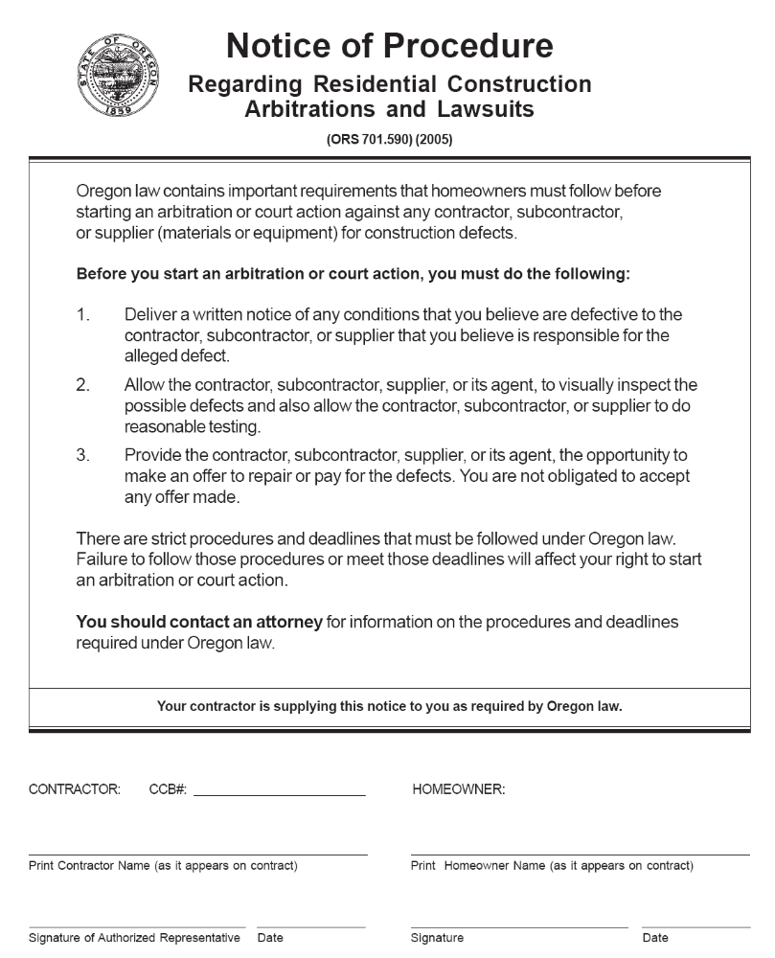
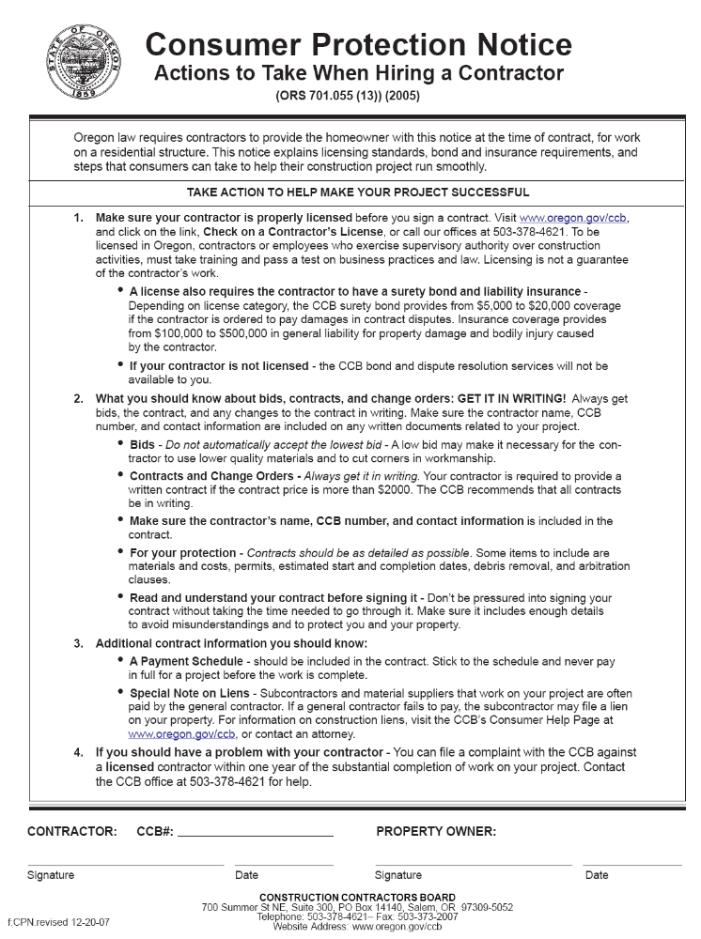
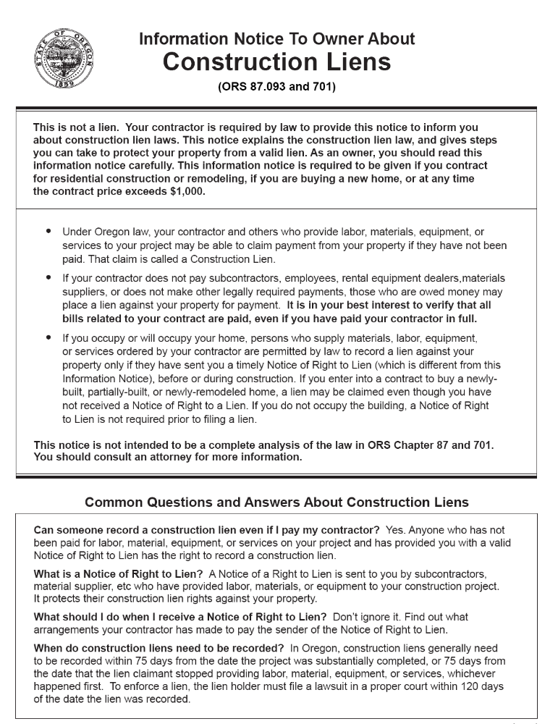
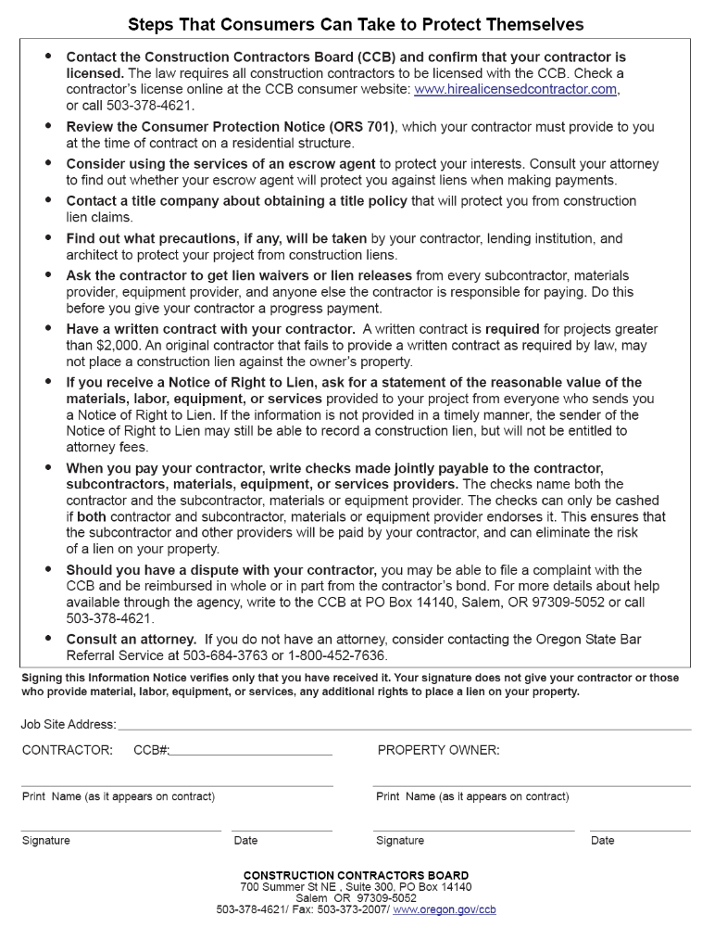
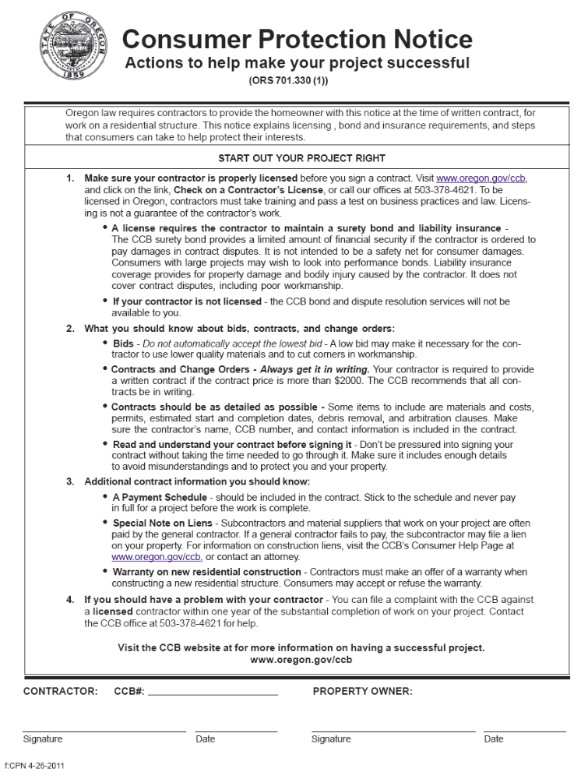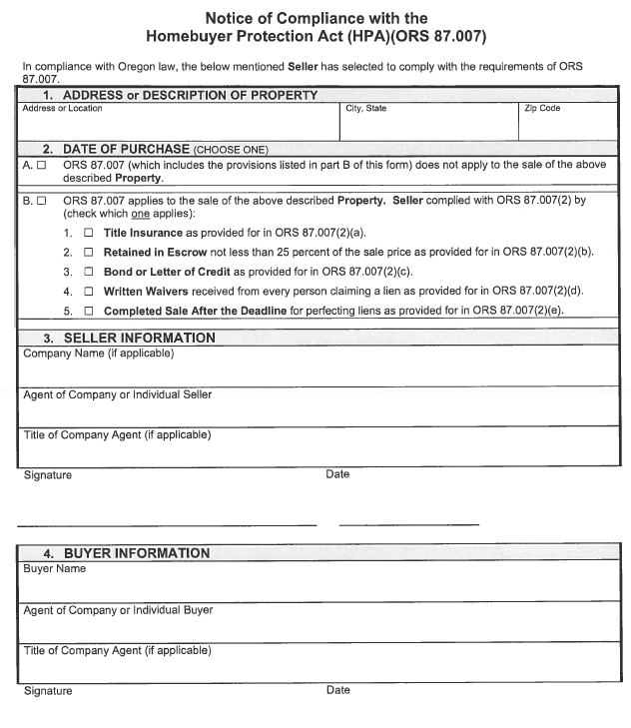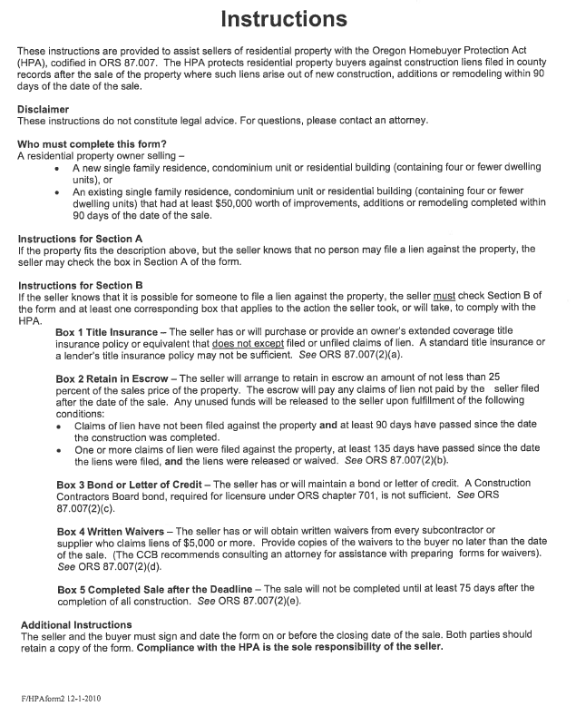
RECEIPT FOR
DECLARATION AND BYLAWS OF
CULLY GREEN CONDOMINIUM
(A PROPOSED CONDOMINIUM)
The undersigned purchaser of Unit No. _____ of the Cully Green Condominium (the "Unit"), hereby acknowledges receipt of a copy of the Proposed Declaration and Bylaws of the Cully Green Condominium, the terms of which relate to the Unit and other units in the Cully Green Condominium.
Dated this _____ day of ____________________, 20__.
Purchaser
Purchaser
THE DECLARANT IS REQUIRED TO RETAIN THIS RECEIPT FOR THREE YEARS.


